Goods Receipt

Home - Personal - Microsoft​ Edge
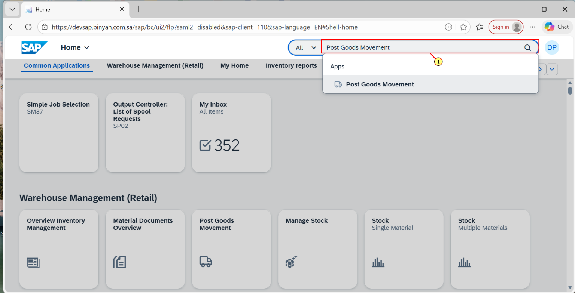
Step | Action
(1) | Search and Open "Post Goods Movement".

Goods Receipt Purchase Order - Personal - Microsoft​ Edge
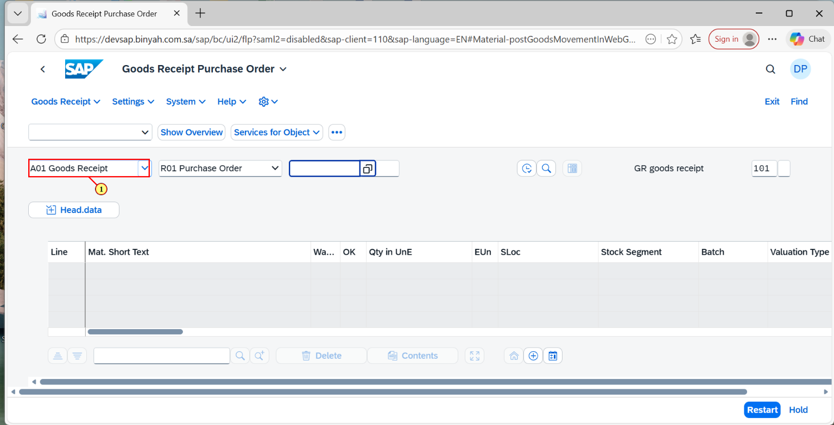
Step | Action
(1) | Select "Goods Receipt".

Goods Receipt Purchase Order - Personal - Microsoft​ Edge
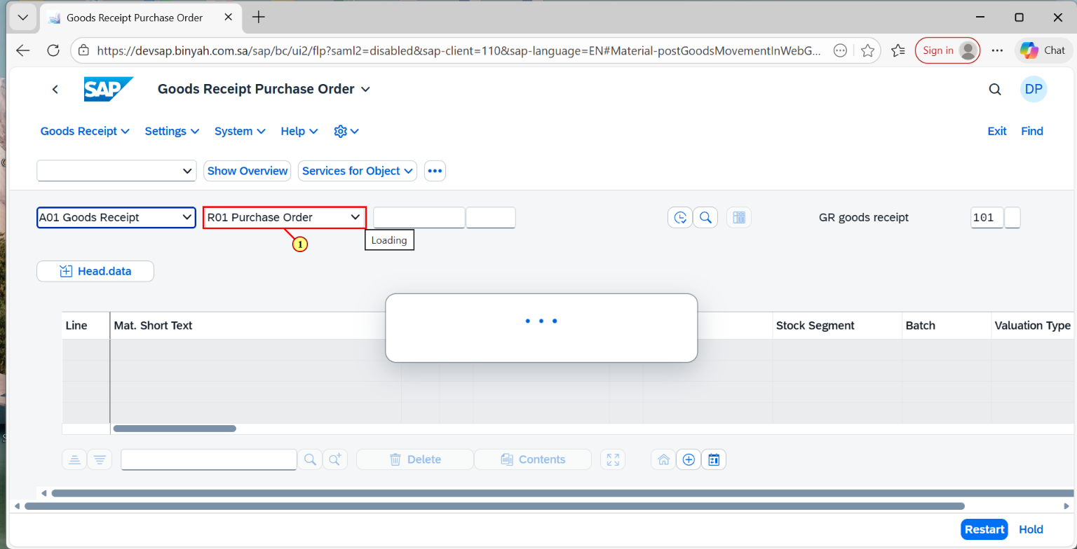
Step | Action
(1) | Select "Purchase Order".

Goods Receipt Purchase Order - Personal - Microsoft​ Edge
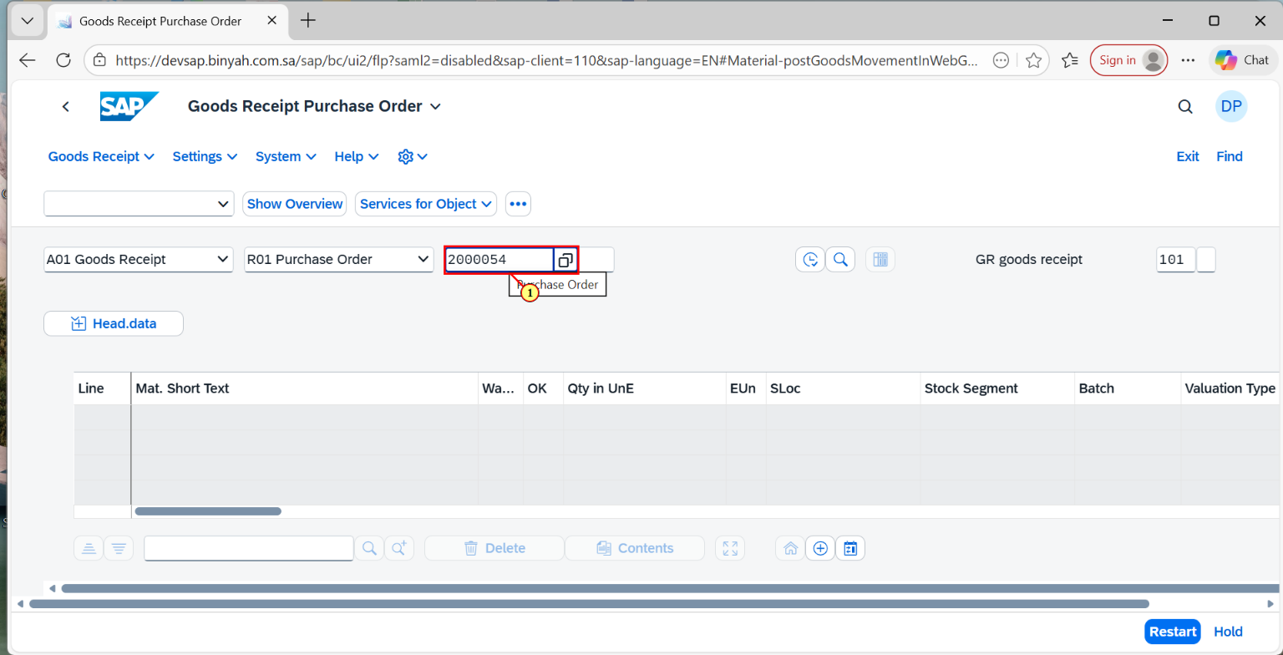
Step | Action
(1) | Select "Purchase Order Number".

Goods Receipt Purchase Order - Personal - Microsoft​ Edge
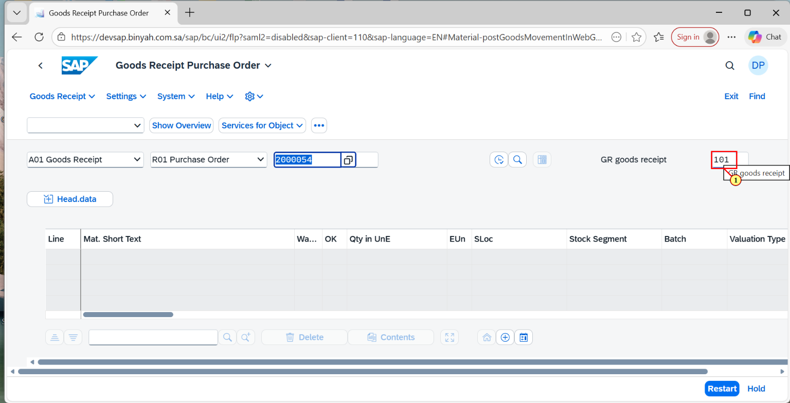
Step | Action
(1) | Verify if the Movement Type is "101".

Goods Receipt Purchase Order 2000054 - Personal - Microsoft​ Edge
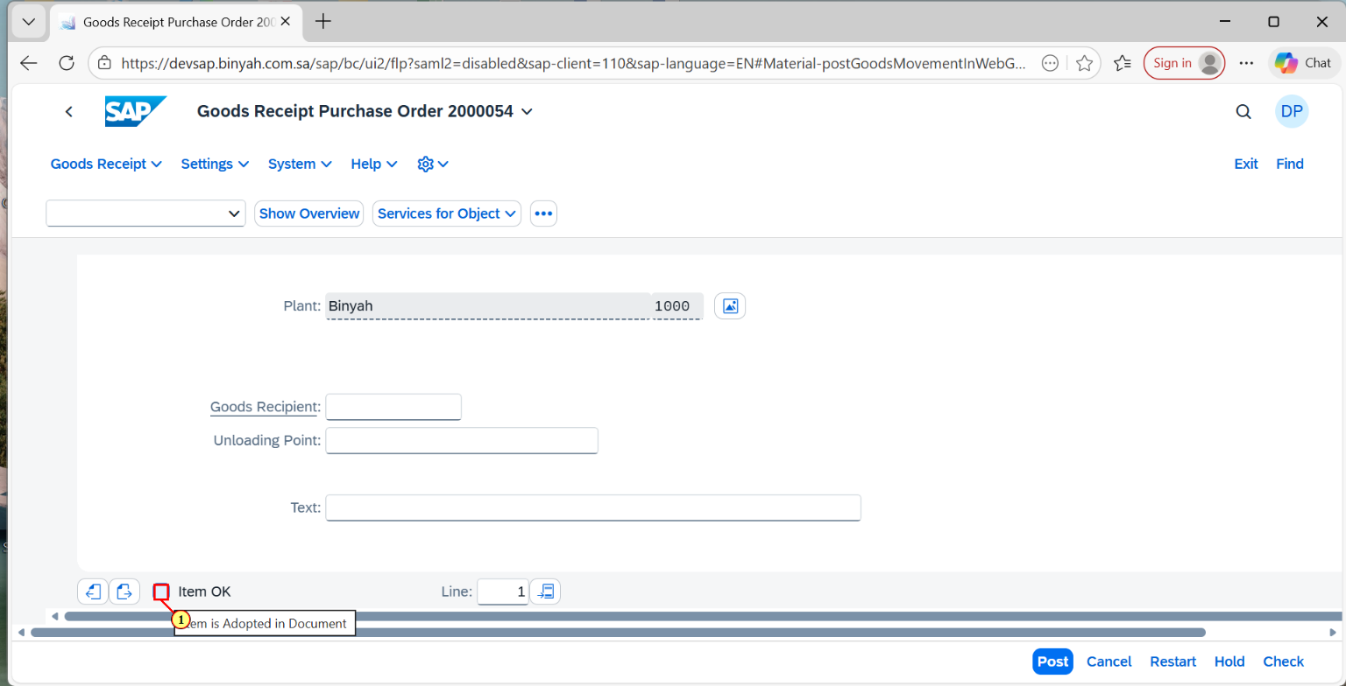
Step | Action
(1) | Select "Item OK".

Goods Receipt Purchase Order 2000054 - Personal - Microsoft​ Edge
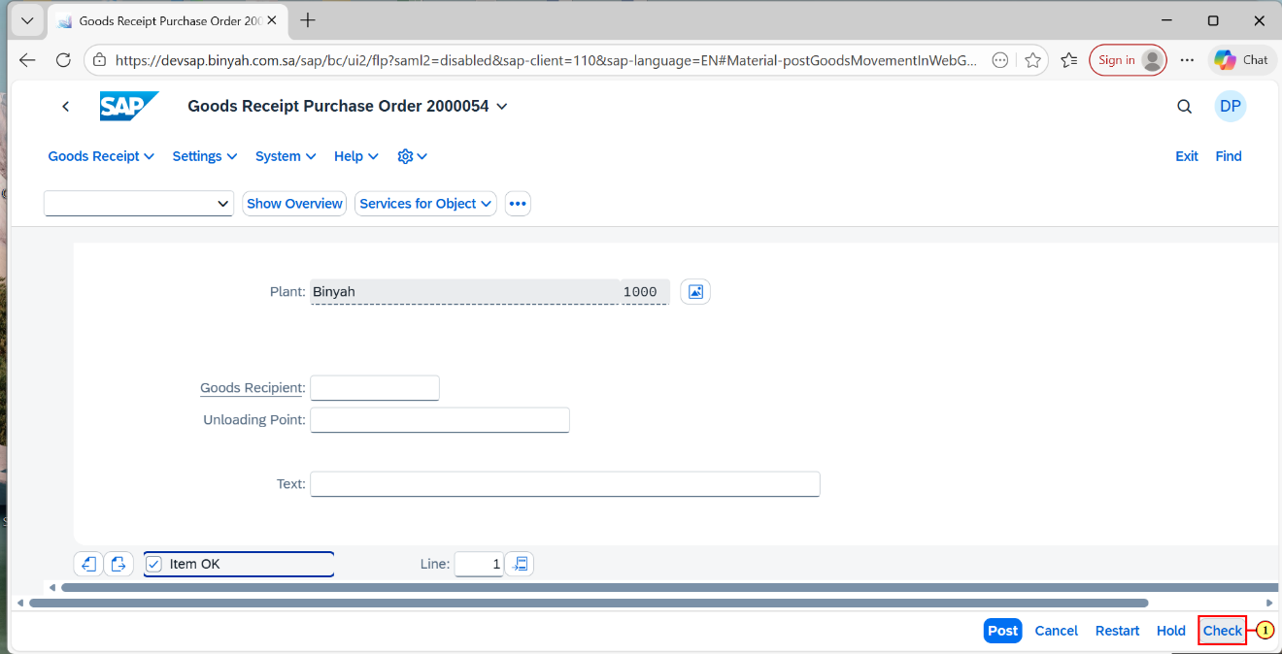
Step | Action
(1) | Click Check "Button".

Goods Receipt Purchase Order 2000054 - Personal - Microsoft​ Edge
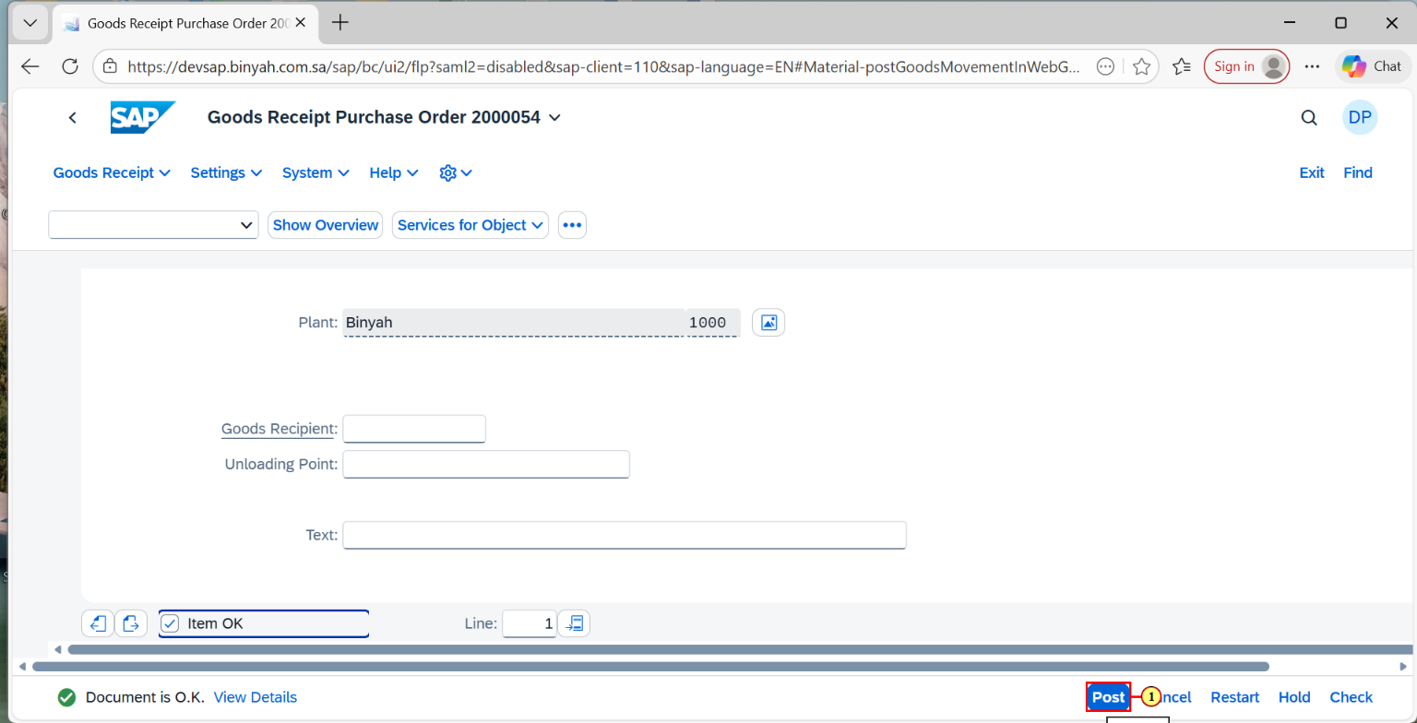
Step | Action
(1) | Click on "Post".

Home - Personal - Microsoft​ Edge
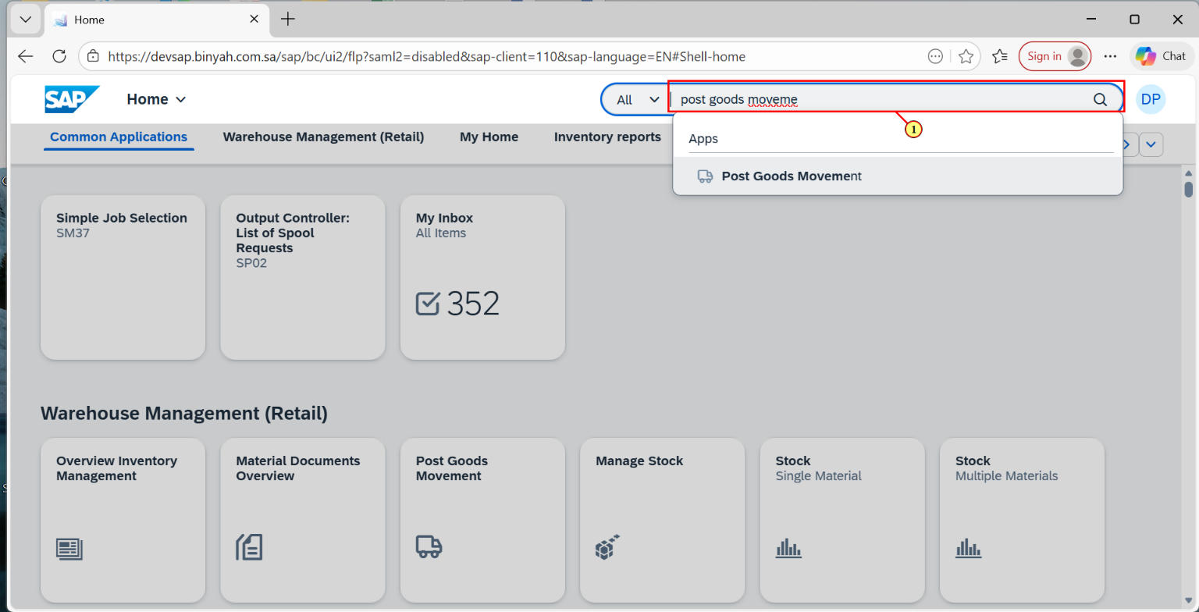
Step | Action
(1) | Again Search and Open "Post Goods Movement".

Display Material Document - Personal - Microsoft​ Edge
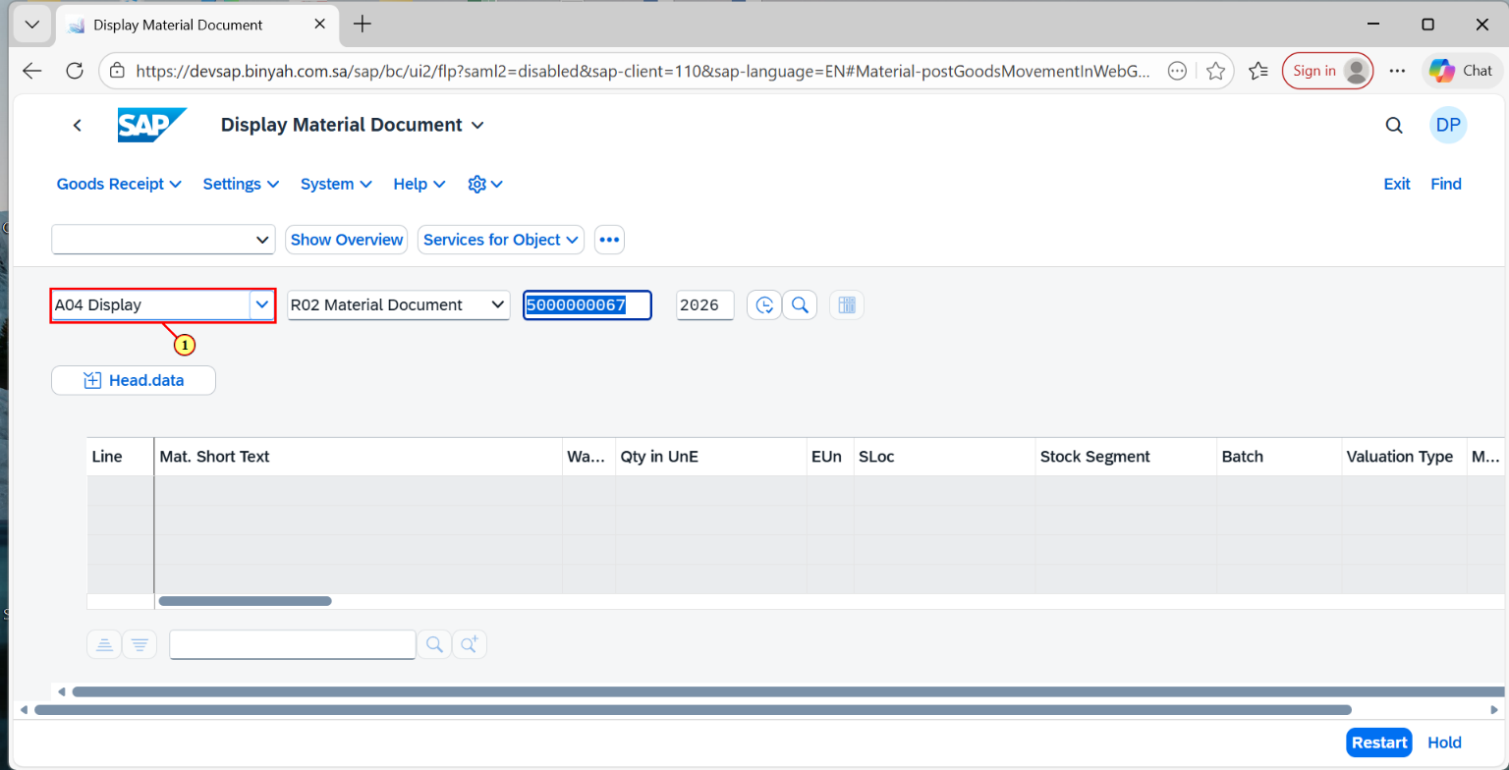
Step | Action
(1) | Select "Display".

Display Material Document - Personal - Microsoft​ Edge
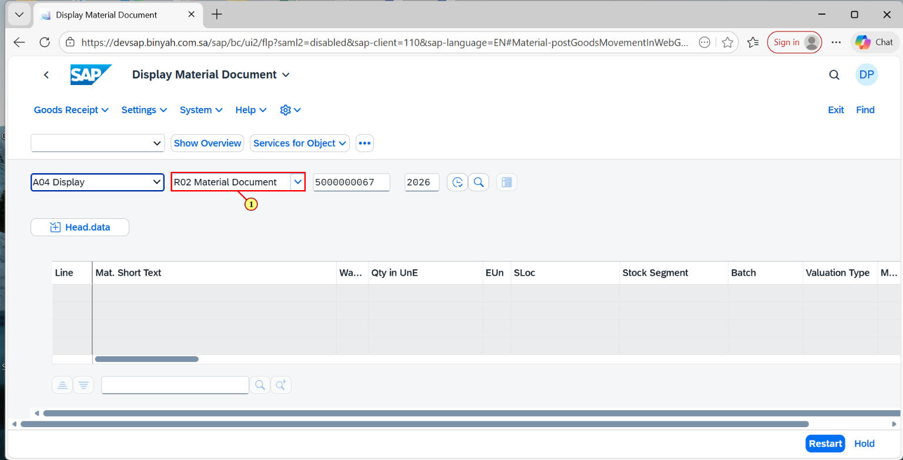
Step | Action
(1) | Select "Material Document".

Display Material Document - Personal - Microsoft​ Edge
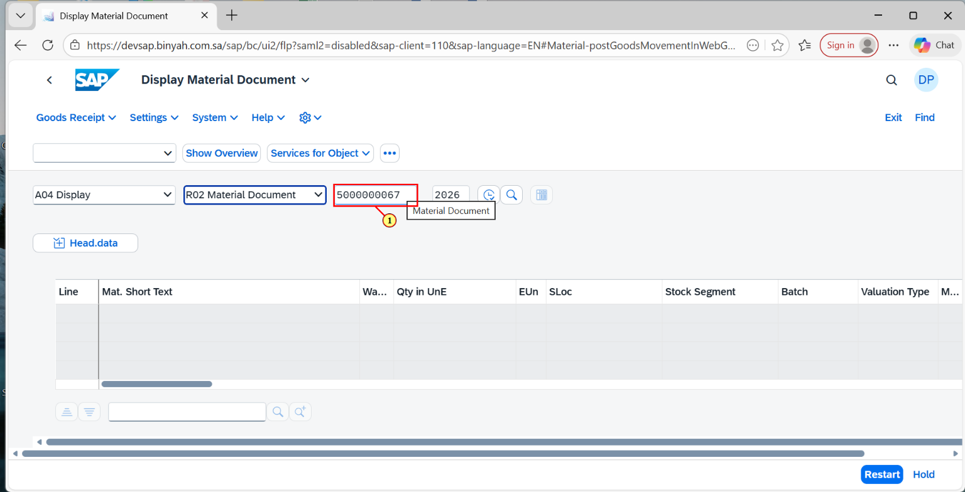
Step | Action
(1) | Enter "Material Document Number".

Display Material Document - Personal - Microsoft​ Edge
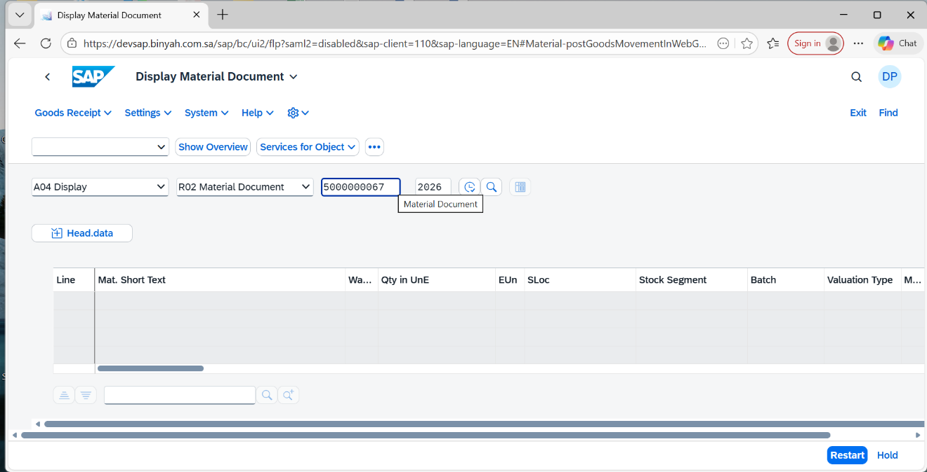
Step | Action
 | Press "Enter".

Display Material Document 5000000067 - Personal - Microsoft​ Edge
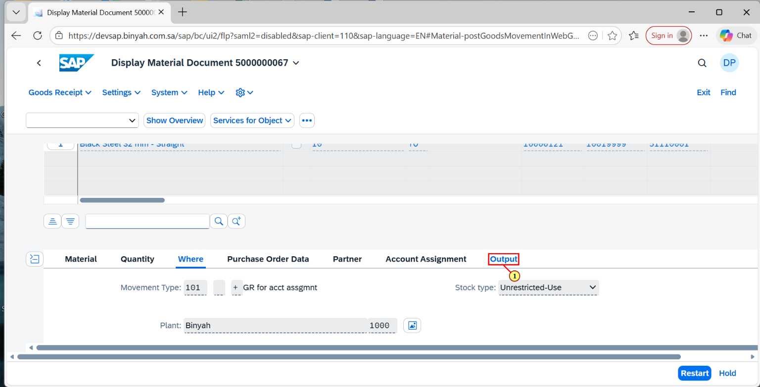
Step | Action
(1) | Click on "Output".

Display Material Document 5000000067 - Personal - Microsoft​ Edge
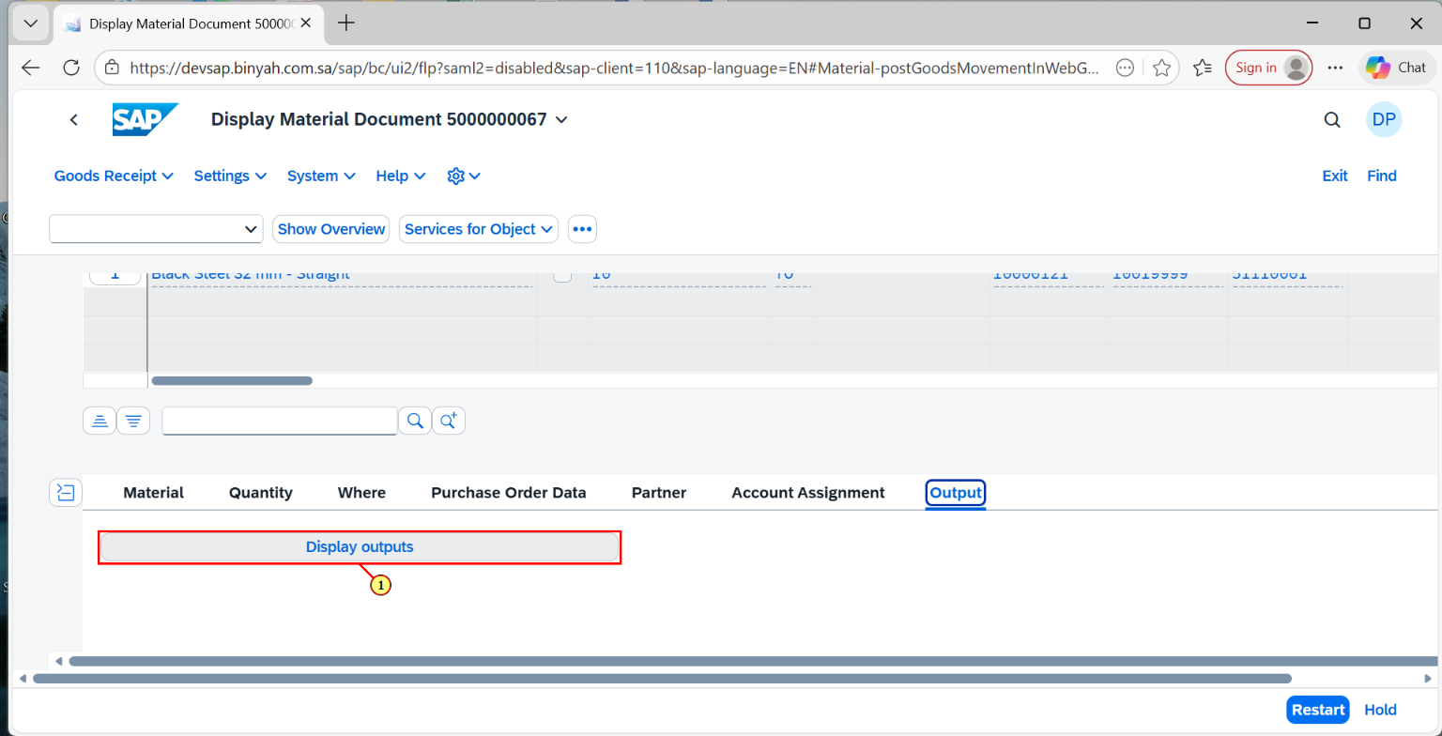
Step | Action
(1) | Click on "Display Outputs".

Material Doc.: Output - Personal - Microsoft​ Edge
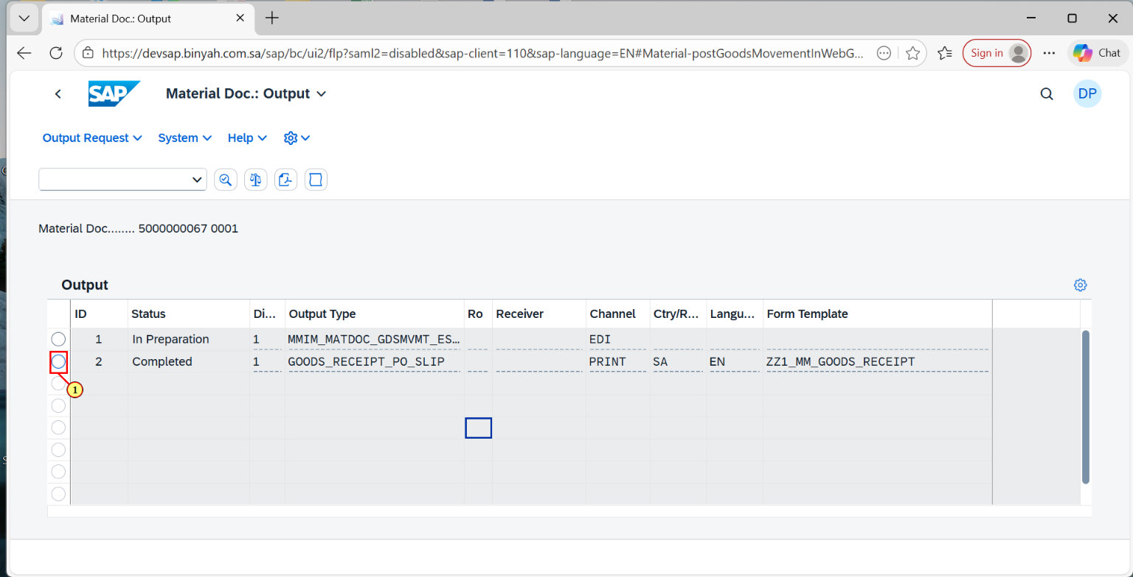
Step | Action
(1) | Select the "Output Document".

Material Doc.: Output - Personal - Microsoft​ Edge
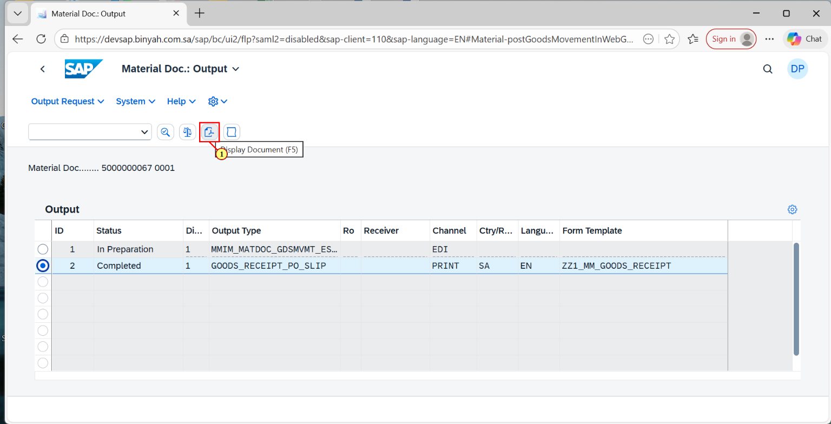
Step | Action
(1) | Click on "PDF Icon".

Material Doc.: Output - Personal - Microsoft​ Edge
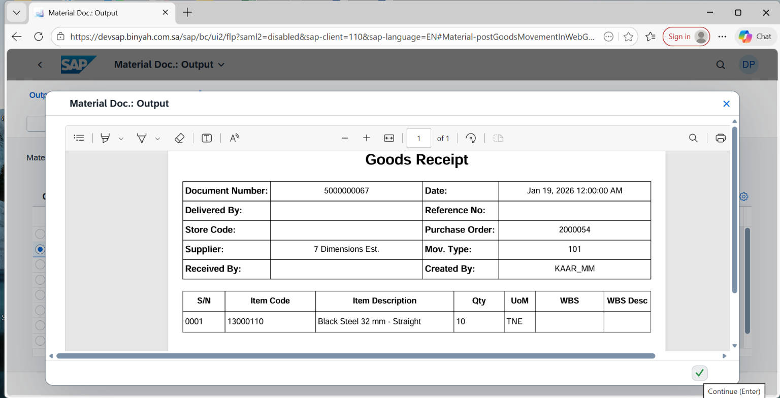
Step | Action
(1) | Material Document is “Displayed”.

